2- In Trigger Process ( Add new Process Switching Voice Release Resources) It will be easy when we want to delete voice resource

Requirement::

As shown in below slides customer require to release resource from trigger process by just inserting subscriber number which further release resource from NEP as well as NMS.

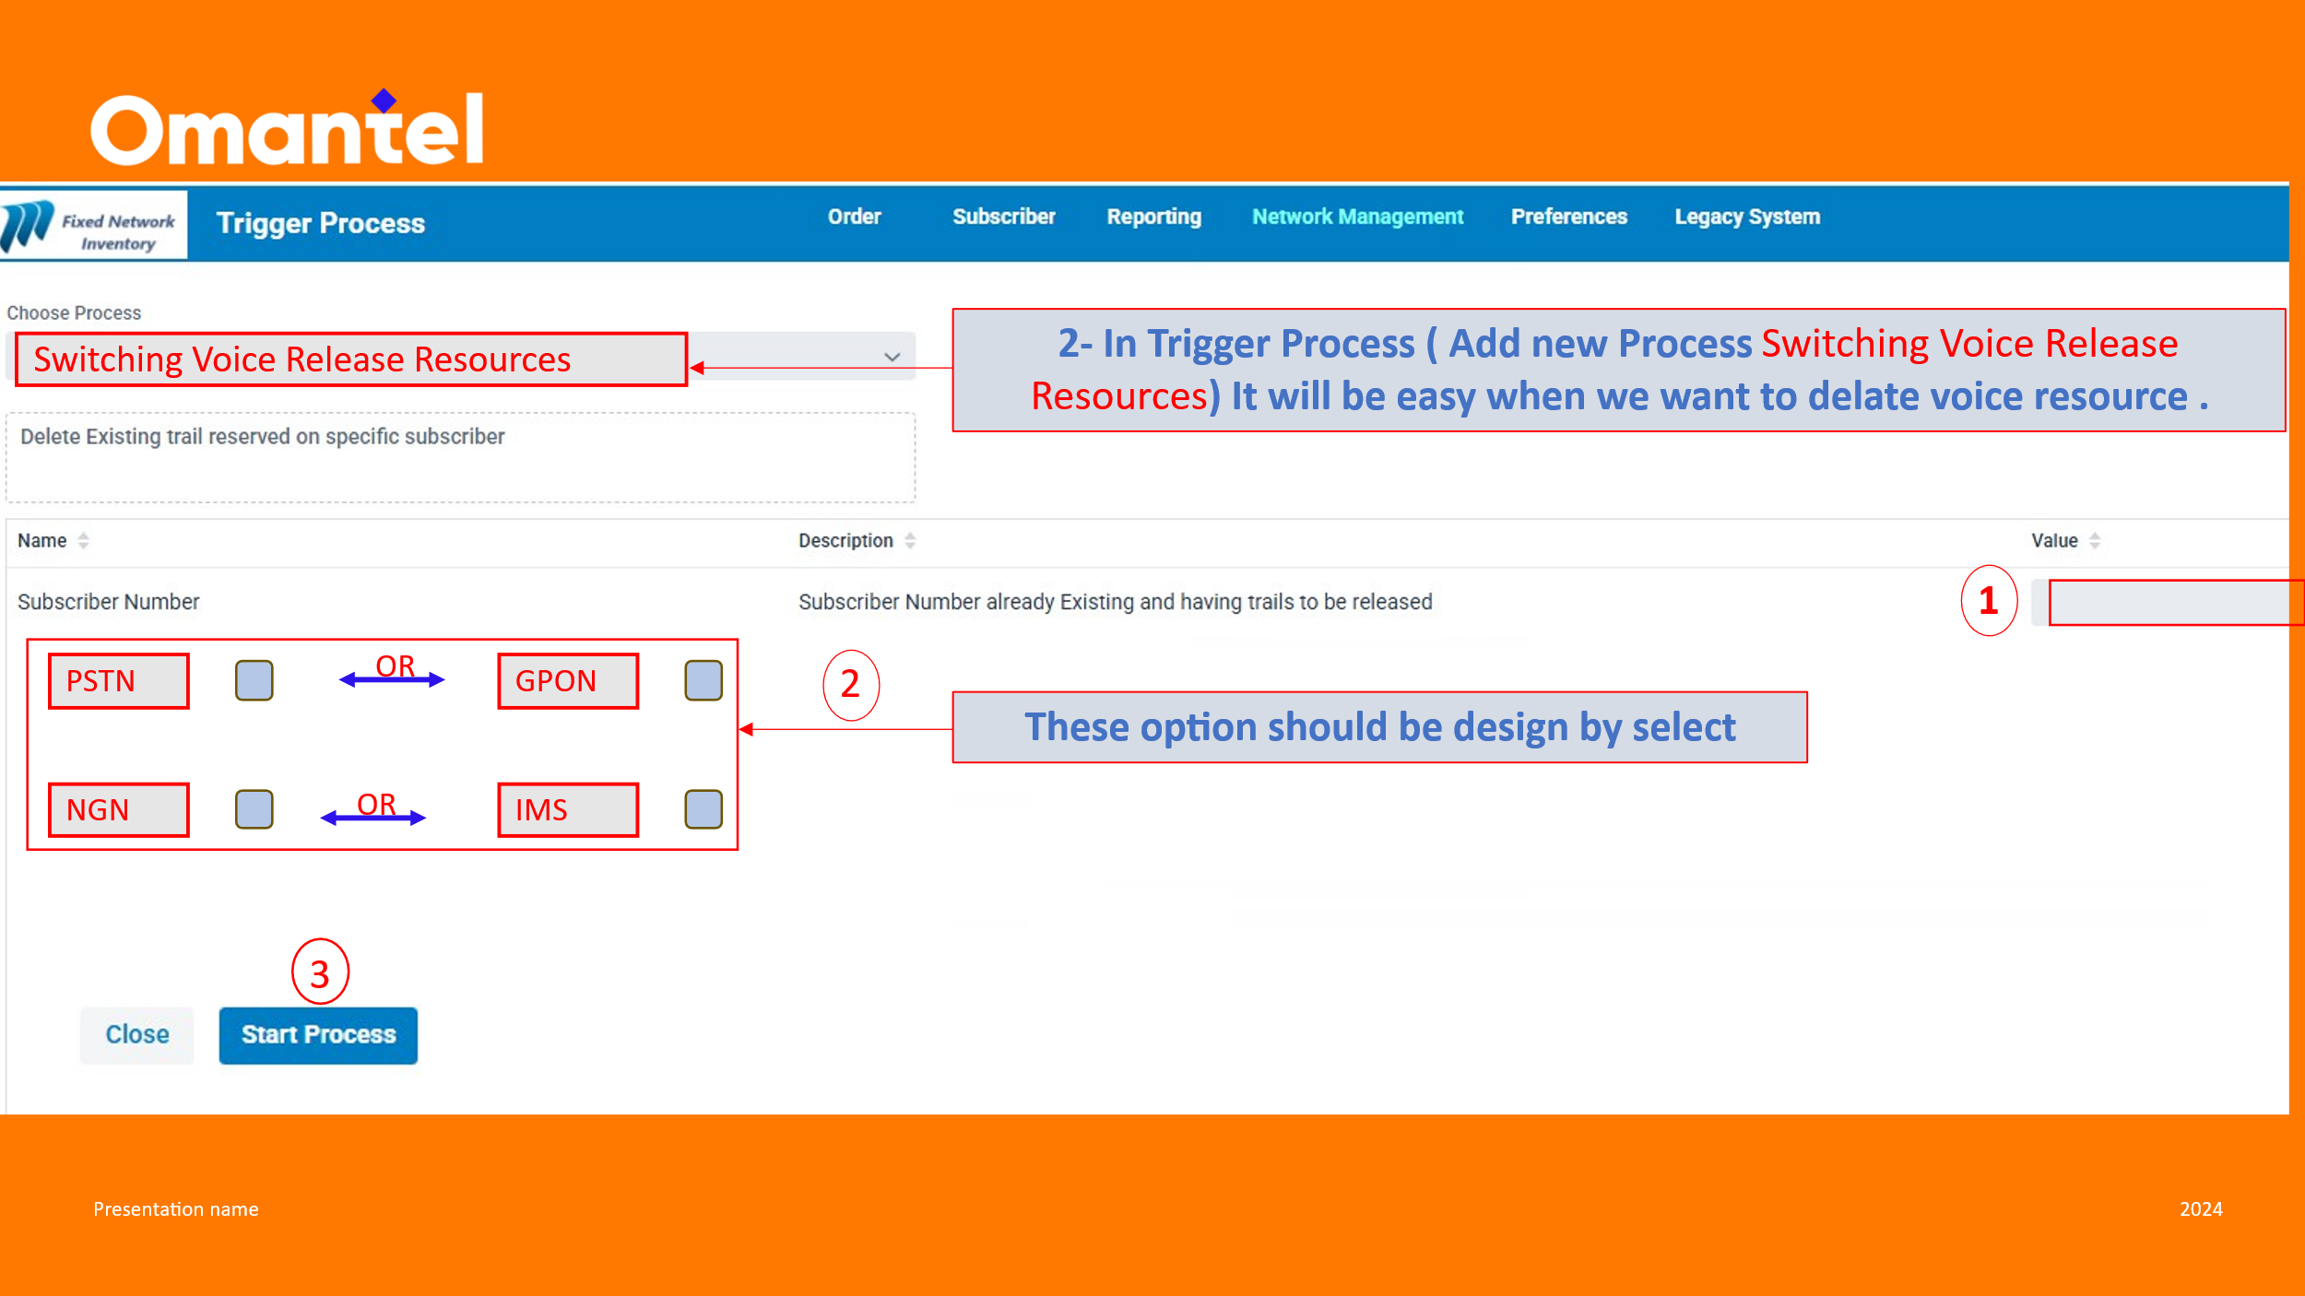

Proposal:

We have already this functionality but with multiple attributes and process vary w.r.t. scenario.For example as shown below separate termination process for copper and fiber.
Now instead of filling all attributes, end user just insert the subscriber and NEP fill below attributes automatically and user may click on start process and as a response NEP reflect success or failure prompt.
Here NE_ID define whether number is on IMS or NGN which will be taken below API i.e
getActiveNEAttributes---This API is use to retrieve NE_ID,AREA Code & Area Name.
OrderID: any alphanumeric value
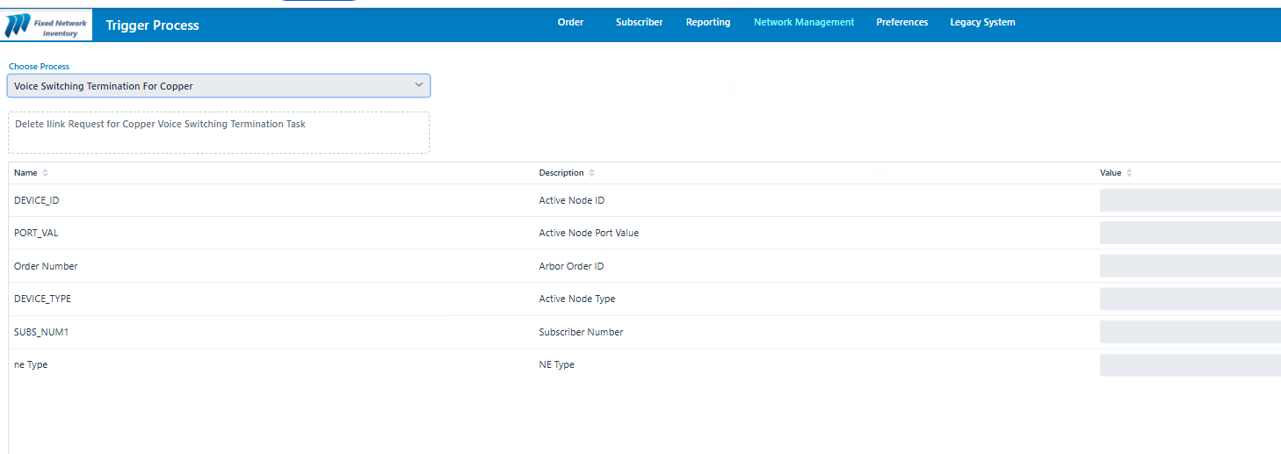

<env:Envelope xmlns:env="http://www.w3.org/2003/05/soap-envelope">
<env:Header />
<env:Body>
<ns2:DeleteRequest xmlns:ns2="http://soa.comptel.com/2011/02/instantlink">
<ns2:RequestHeader>
<ns2:NeType>PSTN</ns2:NeType>
<ns2:OrderNo> any alphanumeric value</ns2:OrderNo>
<ns2:ReqUser>NEP</ns2:ReqUser>
</ns2:RequestHeader>
<ns2:RequestParameters>
<ns2:Parameter name="REQ_OBJ" value="1" />
<ns2:Parameter name="NE_TYPE" value="PSTN" />
<ns2:Parameter name="SUBS_NUM1" value="45005906" />
<ns2:Parameter name="PORT_VAL" value="0-0-0" />
<ns2:Parameter name="DEVICE_ID" value="DUMMY" />
<ns2:Parameter name="ORDER_NO" value="Subscriber No +Timestamp" />
<ns2:Parameter name="DEVICE_TYPE" value="DUMMY />
<ns2:Parameter name="NE_ID" value="HUIMSAGCF/ PSTNIMGR " />
</ns2:RequestParameters>
</ns2:DeleteRequest>
</env:Body>
</env:Envelope>

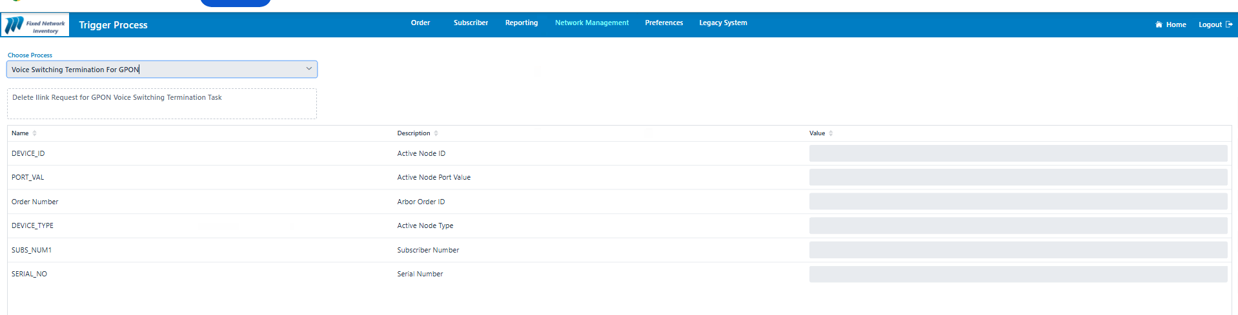

IMS::
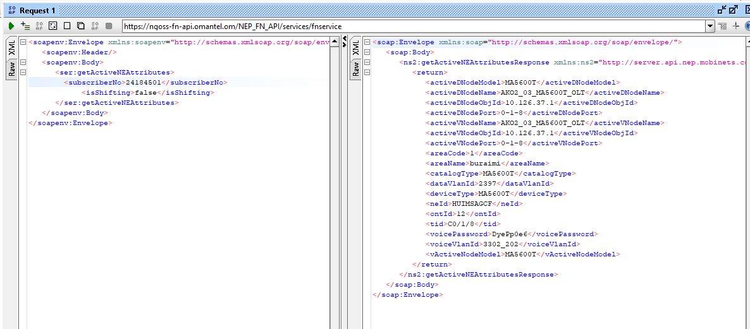

I
<env:Envelope xmlns:env="http://www.w3.org/2003/05/soap-envelope">
<env:Header />
<env:Body>
<ns2:DeleteRequest xmlns:ns2="http://soa.comptel.com/2011/02/instantlink">
<ns2:RequestHeader>
<ns2:NeType>MSAN</ns2:NeType>
<ns2:OrderNo> any alphanumeric value</ns2:OrderNo>
<ns2:ReqUser>NEP</ns2:ReqUser>
</ns2:RequestHeader>
<ns2:RequestParameters>
<ns2:Parameter name="REQ_OBJ" value="5" />
<ns2:Parameter name="NE_ID" value="HUIMSAGCF" />
<ns2:Parameter name="SUBS_NUM1" value="24006243" />
<ns2:Parameter name="DEVICE_ID" value="DUMMY" />
<ns2:Parameter name="DEVICE_TYPE" value="DUMMY" />
<ns2:Parameter name="PORT_VAL" value="0-0-0" />
<ns2:Parameter name="AREA_CODE" value="1" />
<ns2:Parameter name="AREA_NAME" value="BURAIMI" />
<ns2:Parameter name="SERIAL_NO" value="ABCD" />
</ns2:RequestParameters>
</ns2:DeleteRequest>
</env:Body>
</env:Envelope>

NGN::

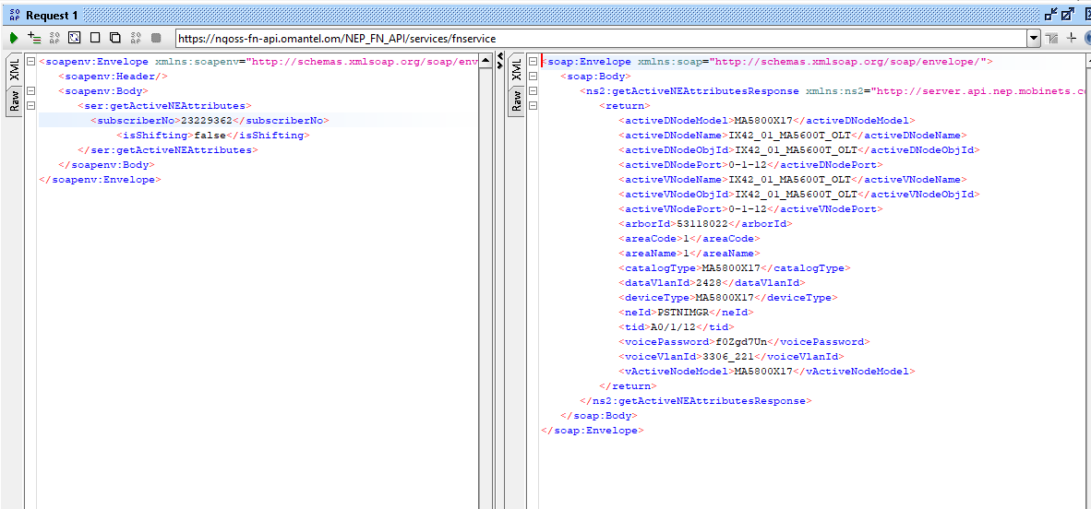
<env:Envelope xmlns:env="http://www.w3.org/2003/05/soap-envelope">
<env:Header />
<env:Body>
<ns2:DeleteRequest xmlns:ns2="http://soa.comptel.com/2011/02/instantlink">
<ns2:RequestHeader>
<ns2:NeType>MSAN</ns2:NeType>
<ns2:OrderNo> any alphanumeric value</ns2:OrderNo>
<ns2:ReqUser>NEP</ns2:ReqUser>
</ns2:RequestHeader>
<ns2:RequestParameters>
<ns2:Parameter name="REQ_OBJ" value="5" />
<ns2:Parameter name="NE_ID" value="PSTNIMGR" />
<ns2:Parameter name="SUBS_NUM1" value="23120100" />
<ns2:Parameter name="PORT_VAL" value="0-0-0" />
<ns2:Parameter name="DEVICE_ID" value="DUMMY" />
<ns2:Parameter name="DEVICE_TYPE" value="DUMMY" />
<ns2:Parameter name="SERIAL_NO" value="ABCD" />
</ns2:RequestParameters>
</ns2:DeleteRequest>
</env:Body>
</env:Envelope>

NEP Enhancement Report::

On the basis of order id we can trace from logs username who has deleted the voice switching.
Format of Report::

Subscriber Number | Request Type | Username | Time | Response
45002310 | Delete Request | W0213873 | 14-04-2026 09:37 | Success/Failure

